MAFAmily Algorithm Steps

(Last Updated on April 1, 2021, by Jj Sergio Canete IV & Samara Sarmiento)

Table of Contents

**Download RStudio Desktop** **2**

If you're having issues opening RStudio: 3

For Mac: 4

For Windows: 5

**Gathering the Application Responses** **6**

**Manipulating the Application .xlsx for R** **6**

**Running the Algorithm in RStudio** **7**

**Sorting** **12**

**Conclusion** **14**

# 

# Download RStudio Desktop

<https://www.rstudio.com/products/rstudio/download/#download>



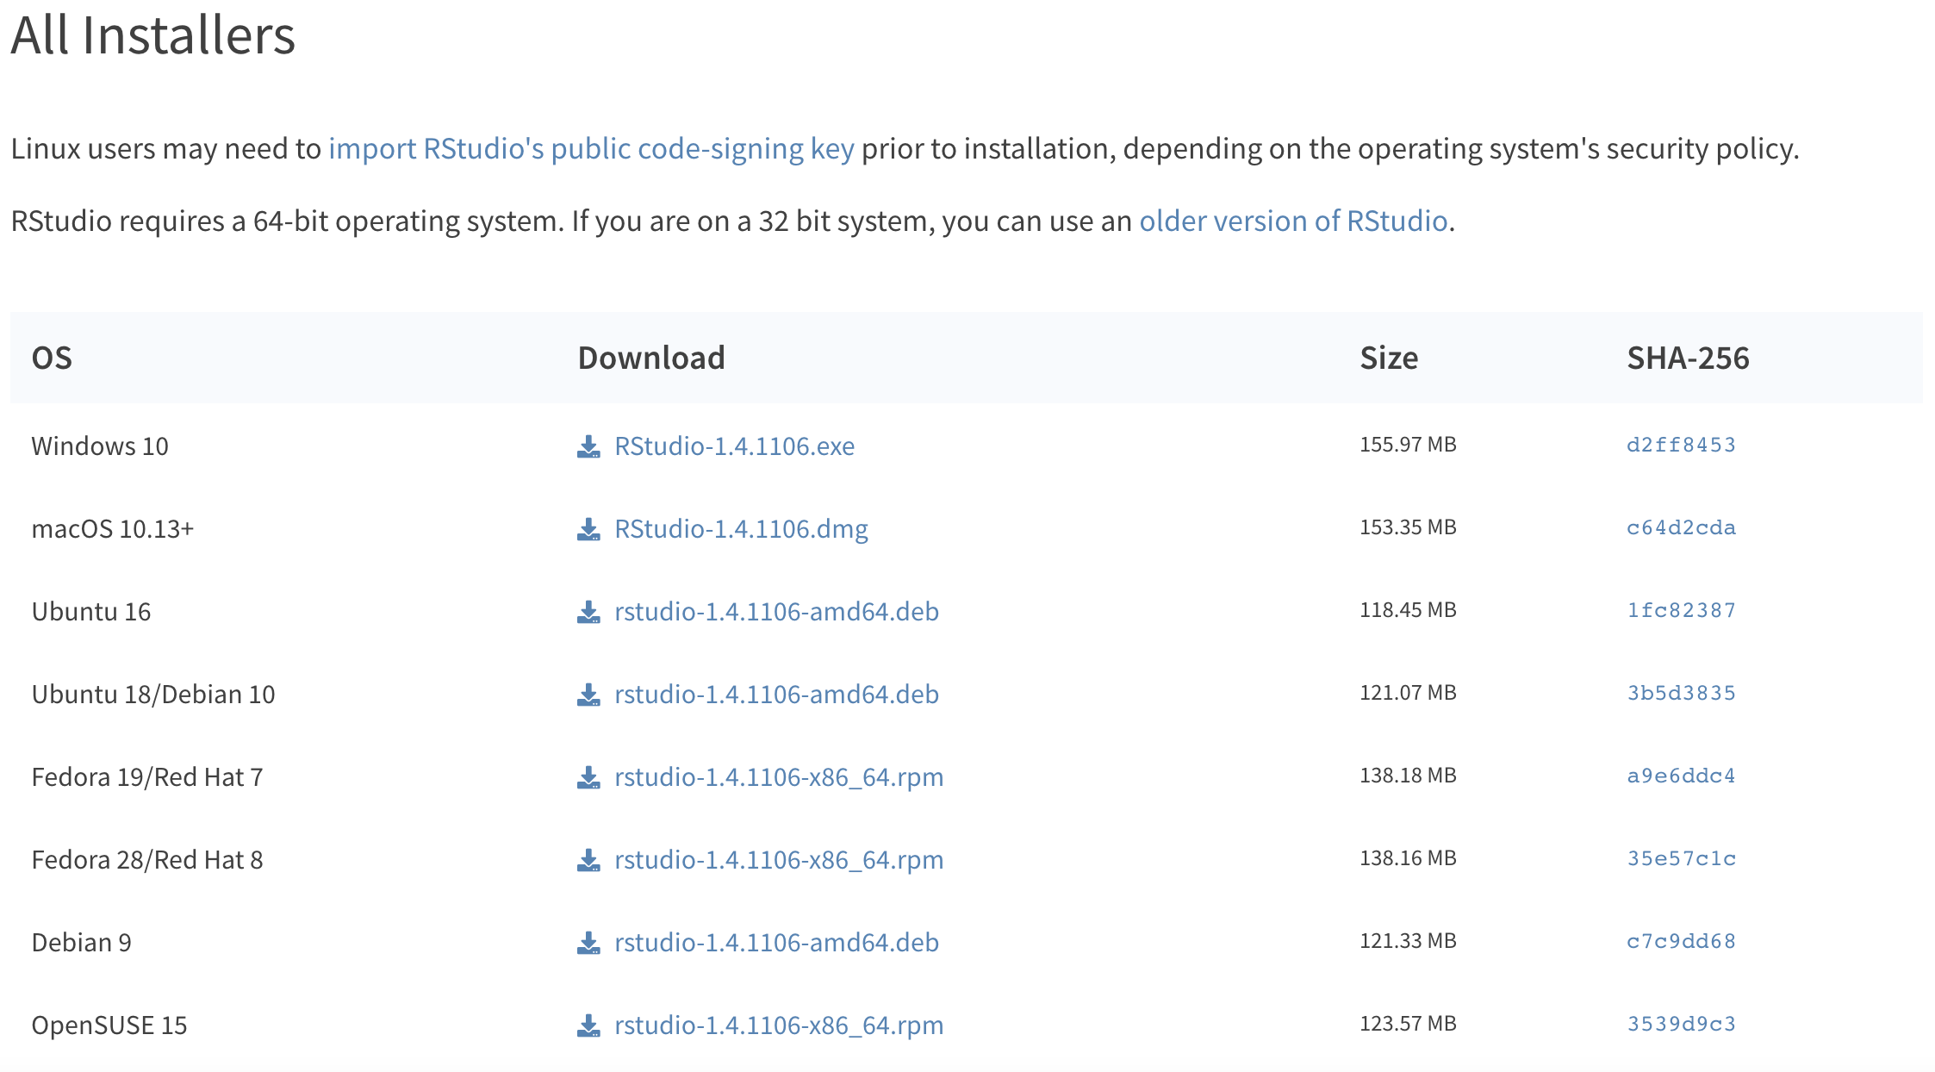

## If you're having issues opening RStudio:

or it says “unable to locate r binary by scanning standard locations”

**Download ‘R binary package’ & install**

<https://cran.r-project.org/>

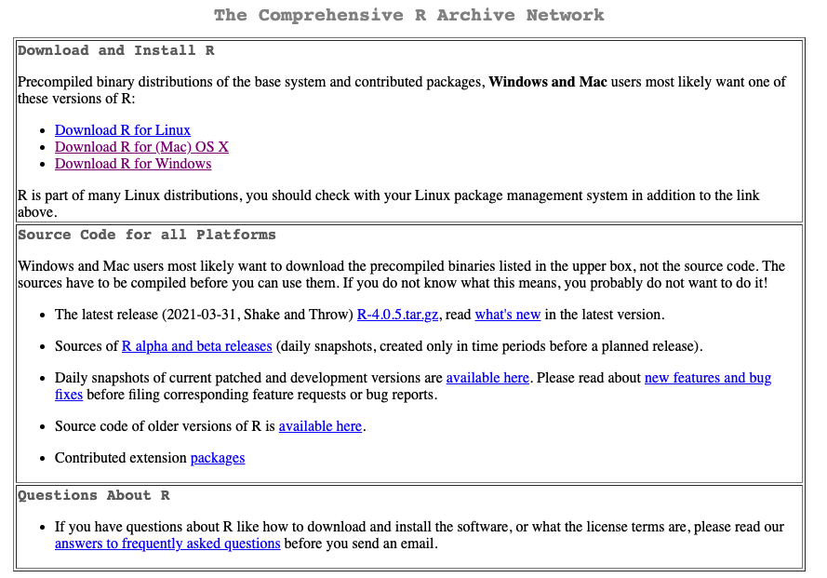

# 

### For Mac:

Download most recent .pkg.

When this was written “R-4.0.5.pkg” is the latest version.

### 

# 

### For Windows:

Click “install R for the first time”

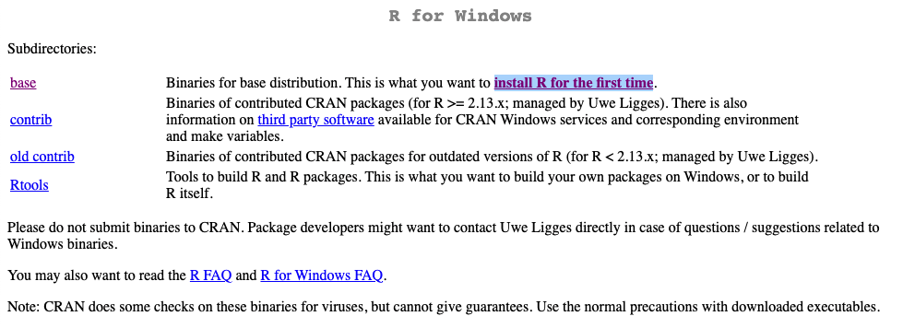

Download R 4.0.5 for Windows

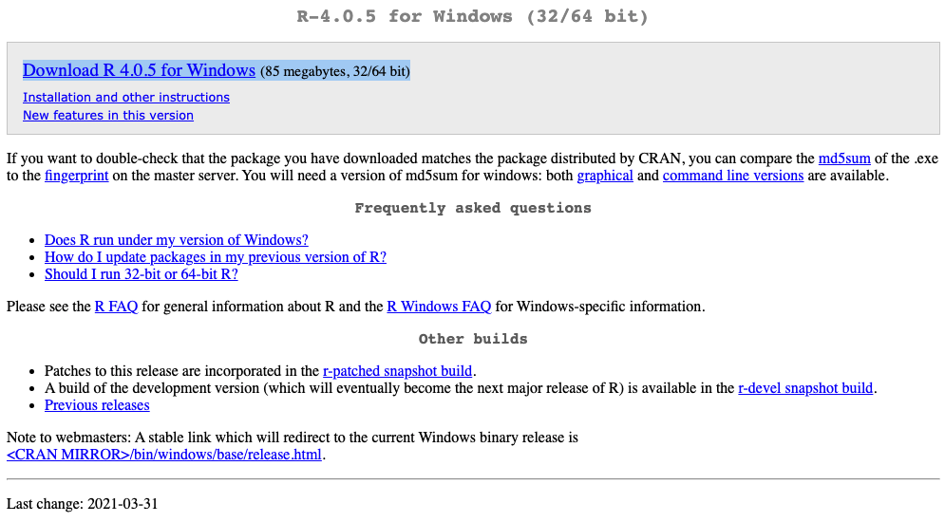

# 

# Gathering the Application Responses

**Go to** [**MAFAmily Application - All Responses**](https://docs.google.com/spreadsheets/d/1rT5bS3oRJNsGD3y-upw7uyFqYnENLp7i5pj85AjvOdw/edit?usp=sharing) **derived from the** [**MAFAmily Application - Editing Version**](https://docs.google.com/forms/d/1l--qnirTAjvAQaTdtx5Y3SLU-_oEUcqwpvajQIFXXoQ/edit?usp=sharing)**.**

* Note - if you would like a link to the actual application, then visit the [MAFA Link Tree](https://linktr.ee/wearemafa).

Find the responses for the current season: Fall or Spring, and copy-and-paste the responses into [application.xlsx](https://drive.google.com/file/d/1tWesy5-tn4_nHhwoJKP4yc8u4mKIgjP-/view?usp=sharing). Make sure to overwrite the data on that file.

# Manipulating the Application .xlsx for R

**The Application File**

After the data has been transferred from the *MAFAmily Application - All Responses* to *application.xlsx*, then the Team Member needs to reconfigure the *application.xlsx*.

Migrate over all of the data from columns P:AC to T:AG. This should create four blank columns *P*, *Q*, *R*, and *S*.

Select Column O, then hold **command** or **ctrl** and deselect the header. Click on **Data**, then click **Split Text to Columns**.

Go to Row 2, and fill-in a zero(0) for columns AH:AT. Select the numbers that you filled in AH2:AT2, then hover over the bottom-right of the selection to obtain the **copy tool** (+). Drag the tool to the last row of data. This shall create the initial point system for every user in the MAFAmily Algorithm.

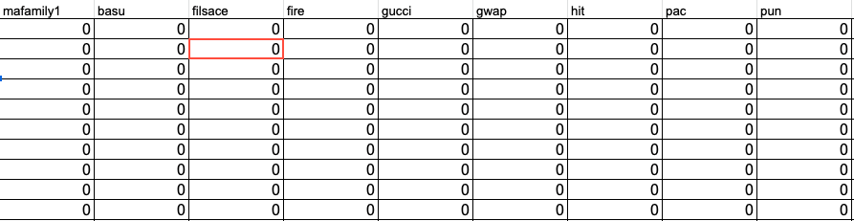

**The MAFAmily Algorithm**

By now, the RStudio Application should have finished downloading.

# Running the Algorithm in RStudio

Tip 1: Chunks are described ‘’’ & ‘’’

So this chunk is from 8 to 16. If the code looks too overwhelming, you can click the arrow and close/hide the chunk.



Step 1: type install.packages(“dplyr”) and click enter

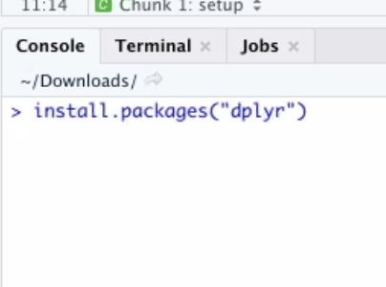

Step 2: Download the application.xlsx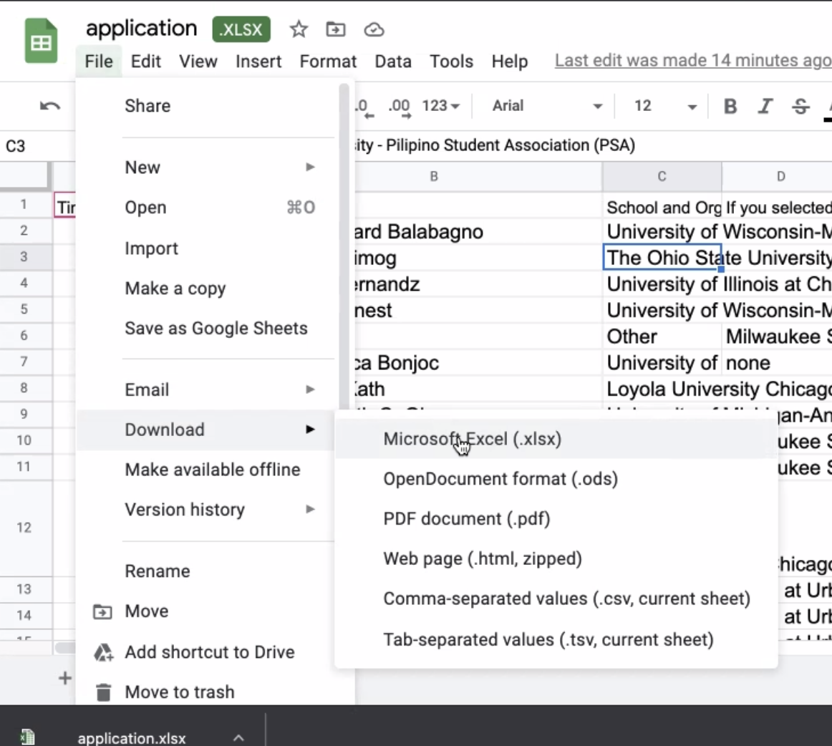

Step 3: Make sure your packages are correctly shown like this:

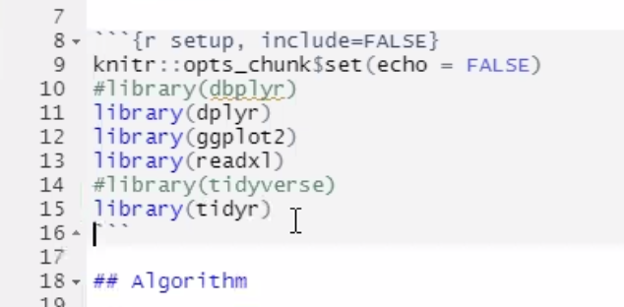

Then run the chunk by clicking the green arrow in the top right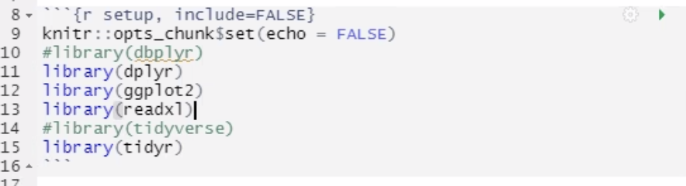

Step 4: (SCREENSHOT)

Import Excel Data

‘Browse’ for the application .xlsx file)

Step 5: (SCREENSHOT)

copy your path, then click ‘cancel’

Your path could look like this “~/Desktop/application.xlsx”

(This depends on where you saved the application.xlsx file on your computer )

Step 6:

On line 23, paste your path from the previous step where the X is within read_excel(“ X ”).

(Just within the “quotation marks”)

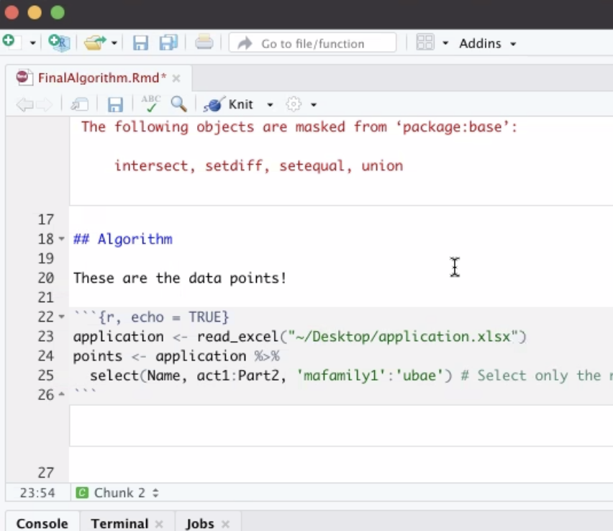

Step 7: (SCREENSHOT)

Go to line 205 and run that chunk

Step 8: (SCREENSHOT)

Find the file “placements.csv” and open it. It might open it in excel.

(RStudio just created this file)

Step 9: (SCREENSHOT)

Within placements.csv, if the first column is numbered (1 to etc), delete that first column

Step 10: (SCREENSHOT)

Open application.xlsx and duplicate the file, rename it “application2.xlsx”

Step 11: (SCREENSHOT)

Copy the numbers within the .csv file, and replace the zeros (0) in application2.xlsx

Step 12: (SCREENSHOT)

Within application2.xlsx, create three new columns at the very end.

top1, top2, top3

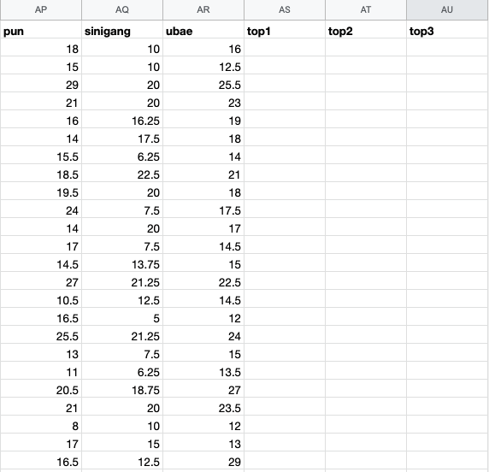

Step 13:

Equation for the first top1 row:

=INDEX($AH$1:$AT$1, 0, MATCH(MAX($AH2:$AT2), $AH2:$AT2,0))

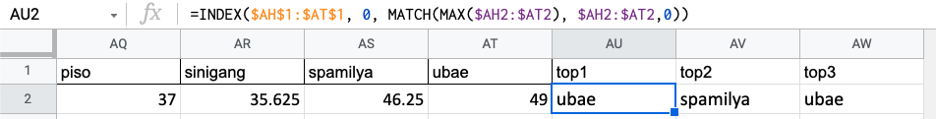

Equation for the first top2 row:

=INDEX($AH$1:$AT$1,0,MATCH(LARGE($AH2:$AT2,2),$AH2:$AT2,0))

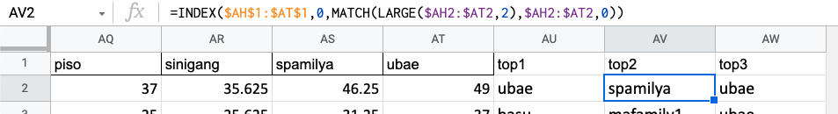

Equation for the first top3 row:

=INDEX($AH$1:$AT$1,0,MATCH(LARGE($AH2:$AT2,3),$AH2:$AT2,0))

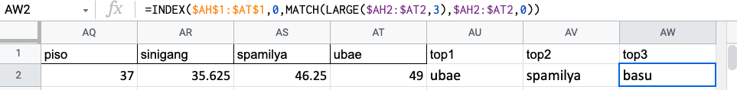

Step 14:

For the first row of top1, hover over the bottom-right of the selection to obtain the **copy tool** (+), then scroll down to select the whole column. Then repeat for top2 & top3 columns.

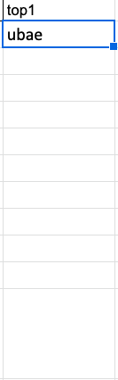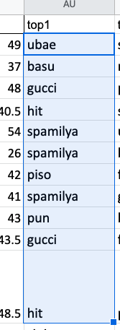

# Sorting

From here, manually finalize each person into a family.

**We recommend sorting by top1/top2/top3 as a priority over sorting by who scored the highest for that individual family.**

Reason for this is because of how the algorithm is made, someone can score really high for multiple families and could even be considered the person who scored the highest for those individual families. However this messes up with sorting because if you only sorted according to who scored the highest for that family, this individual person could theoretically be placed in multiple families. In comparison to if someone scored low for all their families. Because we chose the people who scored highest for everything, it leaves the people who scored low to be picked last which could result in multiple people being placed in the wrong family.

Step 1: Try to evenly divide the total number of new applicants to each family.

Step 2: Prioritize the members who scored the highest for their top 1.

You can do this by formating the top1 column by the A to Z. (It will alphabetically sort the column by the family’s name)

Step 3: Create a new column called “final”, then finalize members into families accordingly.

Then do the same for top 2, then top 3.

Step 4: As a last resort, see who scored the highest for that individual family.

You can do this by sorting that specific family’s column by Z to A.

**Important Tip 1**: Double check the original response form & make sure everyone who applied has been accounted for.

**Important Tip 2**: After sorting/finalizing according to the algorithm, double check their application to make sure they’re suited for that family.

**Important Tip 3:** Make sure to read if anyone has any messages to the outreach team/future MAFAmily Head section of the application.

Ex. People could be coming from different families, so make sure they aren’t placed into the same family and/or placed in a better/active one so they have a good second experience.

Ex1. If they mention a hobby that they like in this description box, it would be a good idea to place them with people who like doing that. So if they mention they like gardening,

**Important Tip 4:** When sorting members into families, it’s important to consider how many members they have in total for that family.

*Helpful Sorting Tip 1*: Within the [MAFAmily Application - All Responses](https://docs.google.com/spreadsheets/d/1rT5bS3oRJNsGD3y-upw7uyFqYnENLp7i5pj85AjvOdw/edit?usp=sharing) doc, there is a tab called “Count” that can help you determine if you’ve sorted everyone.

1. Make sure you’re referencing the right sheet & column
   1. You have to adjust it so it says “Placements - Spring 2021” to the sheet you’re working on.
   2. At the bottom, you can copy and paste the sheet name it into the equation.

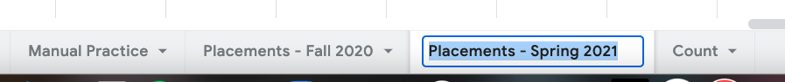

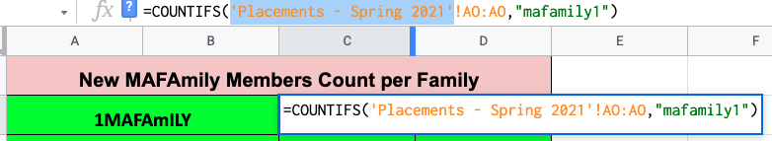

* 1. Make sure that the column it’s referencing is your “final” column in that sheet

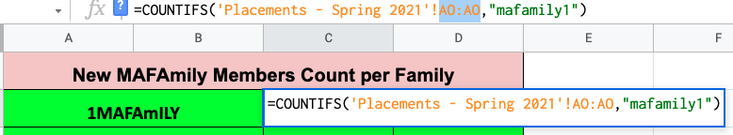

Adjust the “Sorted Total” & “Remaining Total” by the total amount of applicants you received.

So for the Spring 2021 semester we had 33 applicants.

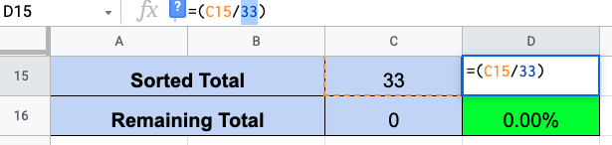

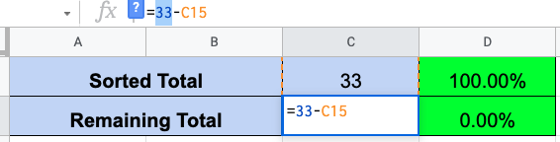

# Conclusion

1. Update the [official roster](https://docs.google.com/spreadsheets/u/1/d/1knJ4Ke3cdI67Lg4nWQolRG0f6ou_JKy1R3kw5l3gzTM/edit?usp=sharing) with the new family members.
2. Notify the family heads of anyone who moved families.
3. Inform the MAFAmily Heads of the newly sorted members.
4. Celebrate! You did it! Hopefully <3